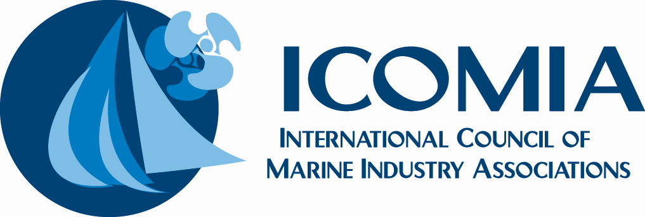

Head of Partnerships, Membership & Industry Engagement
Organisation:
ICOMIA – International Council of Marine Industry Associations
Location:
Flexible / International (UK Hybrid or remote working possible; international travel required)
Reporting to:
CEO
Remuneration:
C£50k plus benefits and incentive scheme

Role Purpose
ICOMIA is seeking a commercially minded, relationship-driven professional to grow its global network of members, sponsors, and strategic partners, while strengthening industry engagement and visibility.
Building on ICOMIA’s established marketing and membership foundations, this role combines partnership development, content-led marketing, sponsorship growth, and industry representation. The post holder will play a central role in increasing membership, securing commercial and in-kind support, and ensuring members clearly understand and benefit from ICOMIA’s value proposition.
This role has scope to evolve and will be shaped around the successful candidate’s experience and impact.

Key Objectives
- Grow ICOMIA’s global sustaining membership base
- Develop and deliver year-on-year sponsorship and partnership programmes
- Increase industry awareness and engagement through content and campaigns
- Strengthen member retention and value delivery
- Expand ICOMIA’s network of senior industry stakeholders

Key Responsibilities

Membership Growth & Business Development
- Identify, approach, and convert new members (associations, companies, and stakeholders)
- Support membership recruitment, retention, and engagement strategies
- Prepare membership proposals, presentations, and follow-up communications
- Maintain and develop CRM and member databases, tracking leads, conversions, and renewals
- Work closely with internal teams to ensure members clearly understand ICOMIA’s role, benefits, and impact

Sponsorship & Partnership Development
- Design and deliver a rolling sponsorship and partners campaign aligned with ICOMIA’s events and strategic priorities
- Develop and sell sponsorship packages including leadership partnerships, event sponsorship, and digital/media opportunities
- Secure revenue-generating and in-kind support for ICOMIA programs and members
- Manage sponsor relationships and ensure deliverables and commitments are met

Marketing, Content & Campaigns
- Plan and implement content-led marketing campaigns to drive industry engagement and awareness
- Create and coordinate marketing content across digital channels
- Support consistent branding and messaging across all ICOMIA communications
- Track and report on marketing performance and engagement metrics

Events & Industry Engagement
- Support marketing and partnership activity around ICOMIA congresses, conferences, webinars, and initiatives
- Represent ICOMIA at international industry events, meetings, and forums
- Build and maintain strong relationships with member associations, sponsors, trade shows, trade media, and industry bodies

Key Performance Indicators
- Volume and effectiveness of industry-facing content and campaigns
- New memberships secured and retained
- Sponsorship and partnership value generated (financial and in-kind)
- Growth and quality of ICOMIA’s industry relationship network
- Member and partner engagement levels

Skills & Experience

Essential
- Proven experience in business development, partnerships, sales, marketing, or membership growth
- Strong written and verbal communication skills
- Ability to manage multiple projects and deadlines
- Commercial mindset with confidence in sales conversations and relationship building
- Experience using CRM systems and digital marketing tools
- Comfortable operating in an international, stakeholder-led environment

Desirable
- Experience in membership organisations, trade associations, or federated bodies
- Background in the leisure marine industry or related B2B sectors
- Experience in sponsorship sales, partnership activation, or events-based revenue
- Exposure to international events, conferences, or multi-market projects

Personal Attributes
- Proactive, organised, and results-driven
- Credible, confident, and diplomatic communicator
- Comfortable working independently and as part of a small international team
- Genuine interest in the global leisure marine industry and sustainability topics

Role Level & Remuneration
This is envisaged as a mid- to senior-level role. ICOMIA is open to shaping the position around the right candidate and is willing to consider a competitive base salary alongside an incentive or commission-linked structure aligned to measurable growth and commercial impact.
A business case will be developed based on the successful candidate’s anticipated contribution.

What We Offer
- A unique opportunity to work at the heart of the global leisure marine industry
- Exposure to international stakeholders, policy, sustainability, and technical initiatives
- A varied, high-profile role combining marketing, partnerships, and strategic engagement
- Flexible working arrangements, subject to role requirements

